**ITA144-ETHICAL HACKING**

**LAB MANUAL**

**Exercise No 1:** **Nmap Scan**

**Aim:**

To install and perform Nmap scan (note :- you may use ip address or website name)

**Procedure:**

Step 1: Open Nmap from Kali Linux (Goto Applications->select Information Gathering->select

Nmap)

Step 2: Perform different types of scan

(Tcp, Udp, Ack, Syn, Fin, Null, Xmas, Rpc, Idle)- scan types

**Scanning Techniques**

|  |  |  |
| --- | --- | --- |
| **Flag** | **Use** | **Example** |
| **-sS** | **TCP syn port scan** | **nmap -sS 192.168.1.1** |
| **-sT** | **TCP connect port scan** | **nmap -sT 192.168.1.1** |
| **–sU** | **UDP port scan** | **nmap –sU 192.168.1.1** |
| **–sA** | **TCP ack port scan** | **nmap –sA 192.168.1.1** |

Step 3:-

To perform host discovery

|  |  |  |
| --- | --- | --- |
| -Pn | only port scan | nmap -Pn192.168.1.1 |
| -sn | only host discover | nmap -sn192.168.1.1 |
| -PR | arp discovery on a local network | nmap -PR192.168.1.1 |
| -n | disable DNS resolution | nmap -n 192.168.1.1 |

Step4:-

**Port Specification**

|  |  |  |
| --- | --- | --- |
| **Flag** | **Use** | **Example** |
| **-p** | **specify a port or port range** | **nmap -p 1-30 192.168.1.1** |
| **-p-** | **scan all ports** | **nmap -p- 192.168.1.1** |
| **F** | **fast port scan** | **nmap -F 192.168.1.1** |

Step 5:-

***Service Version and OS Detection***

|  |  |  |
| --- | --- | --- |
| Flag | Use | Example |
| -sV | detect the version of services running | nmap -sV 192.168.1.1 |
| -A | aggressive scan | nmap -A 192.168.1.1 |
| -O | detect operating system of the target | nmap -O 192.168.1.1 |

Step 6:-

Timing and Performance

|  |  |  |
| --- | --- | --- |
| Flag | Use | Example |
| -T0 | paranoid IDS evasion | nmap -T0 192.168.1.1 |
| -T1 | sneaky IDS evasion | nmap -T1 192.168.1.1 |
| -T2 | polite IDS evasion | nmap -T2 192.168.1.1 |
| -T3 | normal IDS evasion | nmap -T3 192.168.1.1 |
| -T4 | aggressive speed scan | nmap -T4 192.168.1.1 |
| -T5 | insane speed scan | nmap -T5 192.168.1.1 |

Output:

Result:

**Exercise No 2:** **Cracking the Password**

# **Aim:** To Cracking the Password using Hydra, Johny Tools in Kali Linux Operating Systems.

**Procedure:**

Step 1: To open it, go to Applications → Password Attacks → Online Attacks → hydra.

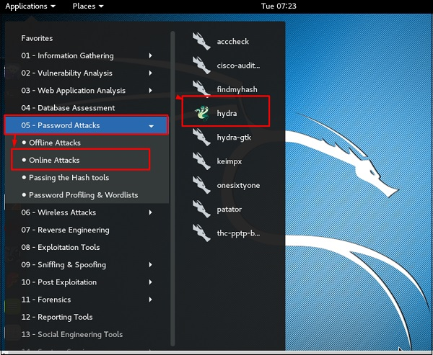

It will open the terminal console, as shown in the following screenshot.

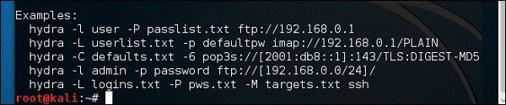

In this case, we will brute force FTP service of metasploitable machine, which has IP 192.168.1.101



We have created in Kali a word list with extension ‘lst’ in the path usr\share\wordlist\metasploit.

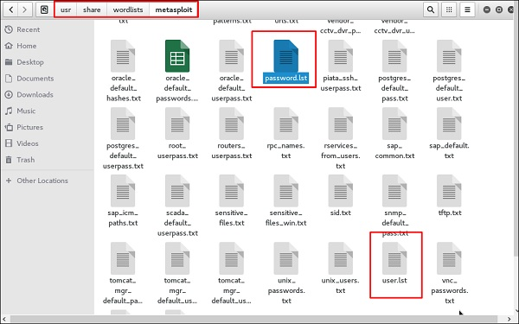

The command will be as follows −

hydra -l /usr/share/wordlists/metasploit/user -P

/usr/share/wordlists/metasploit/ passwords ftp://192.168.1.101 –V

where –V is the username and password while trying



As shown in the following screenshot, the username and password are found which are msfadmin:msfadmin

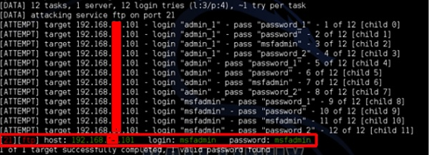

## **Johnny Tool**

Step 1: To open it, go to Applications → Password Attacks → johnny.

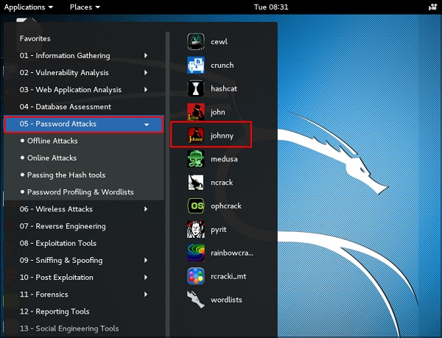

In this case, we will get the password of Kali machine with the following command and a file will be created on the desktop.

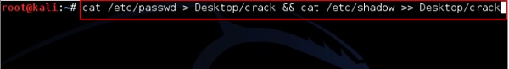

Click “Open Passwd File” → OK and all the files will be shown as in the following screenshot.

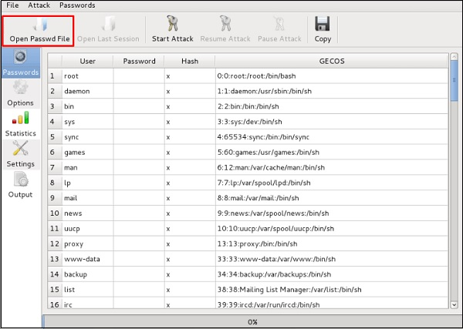

Click “Start Attack”.

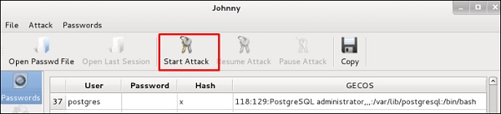

After the attack is complete, click the left panel at “Passwords” and the password will be unshaded.

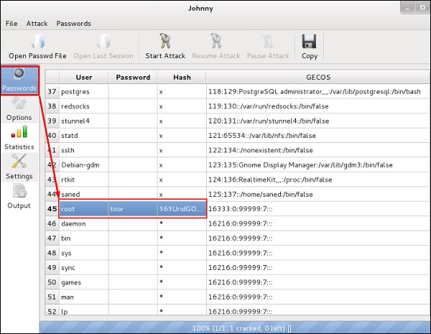

## **John Tool**

Step1: To start it, open the Terminal and type “john”.

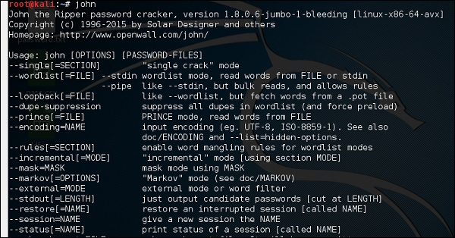

In case of unshadowing the password, we need to write the following command −

root@kali:~# unshadow passwd shadow > unshadowed.txt

**Exercise No 3:** **Vulnerability Access Scan Using Nessus**

**Aim :** To Download and install Nessus tool and perform a Vulnerability Access scan in kali Linux Operating systems.

Step 1:- <https://www.tenable.com/downloads/nessus?loginAttempted=true>

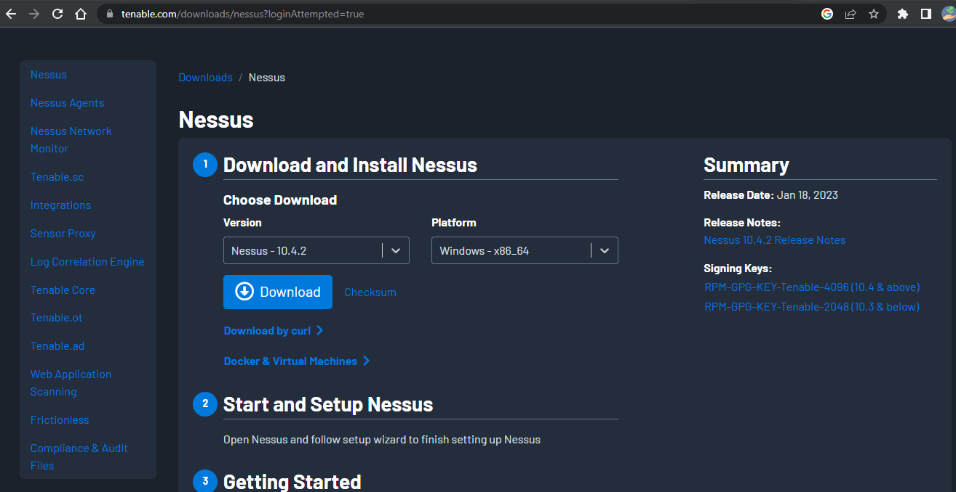

Step 2: Choose your OS and download , install

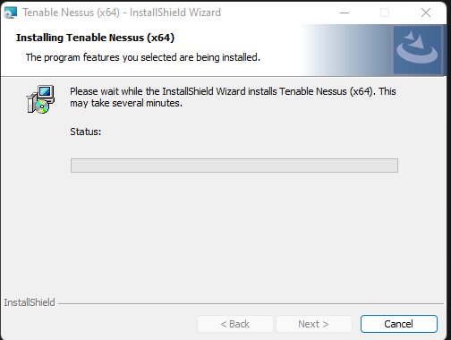

Step 3: Once installation is completed it will open in default browser

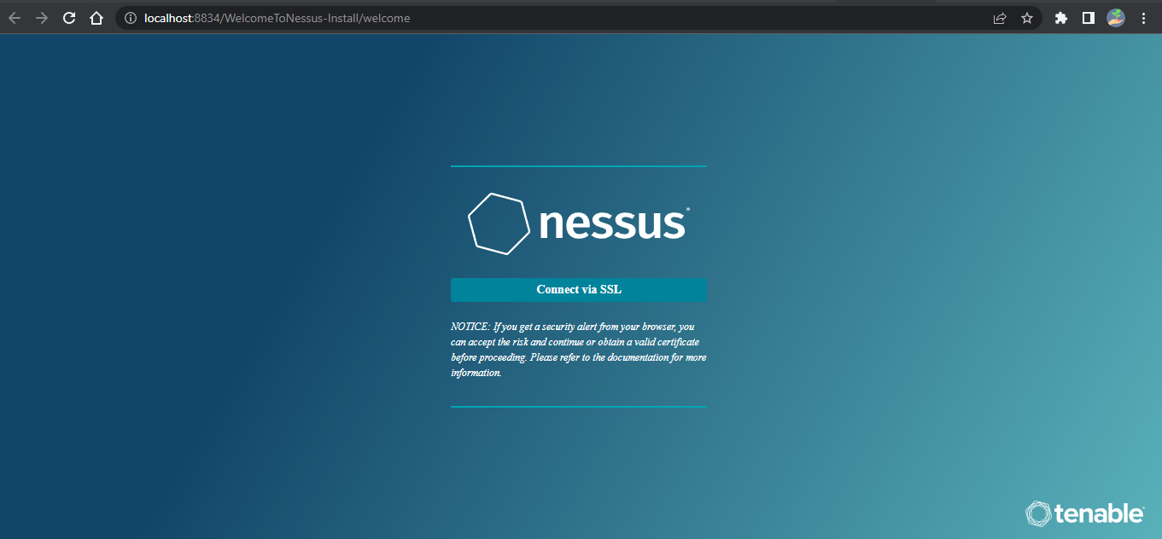

Step 5:- (click on the proceed to local host)

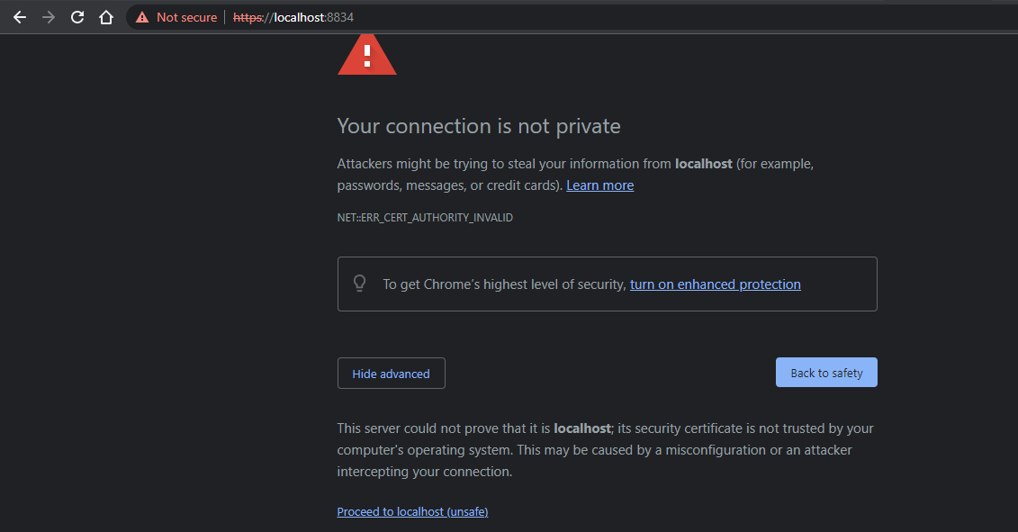

Step 6:- Please choose the Nessus Expert

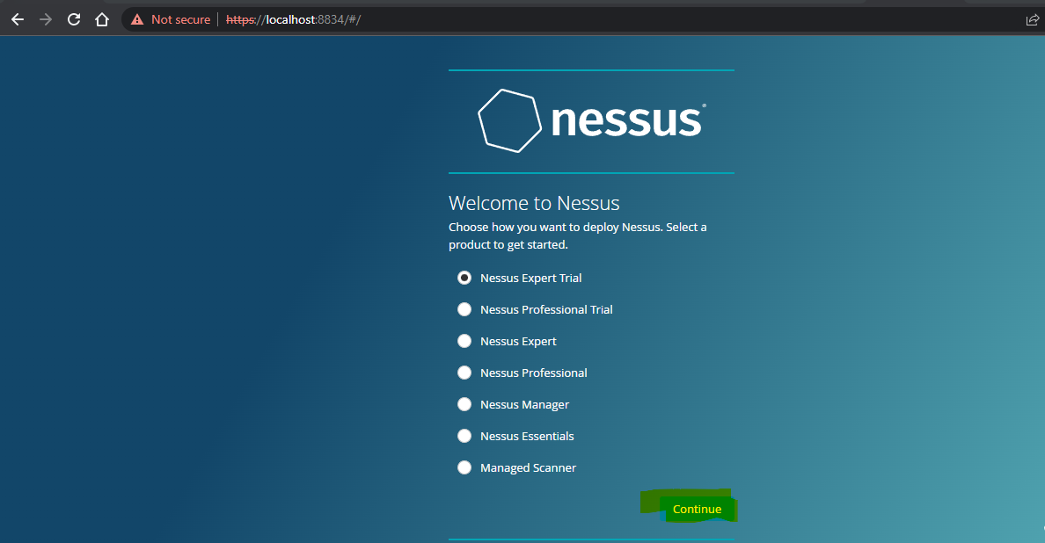

Step 7: Click on continue

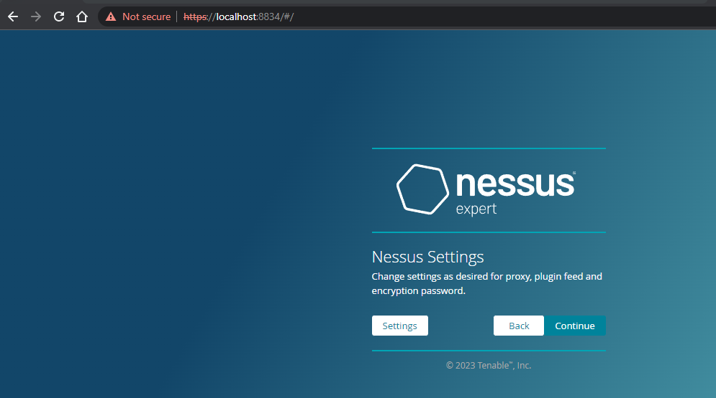

Step 8:- Register with your organizational email id

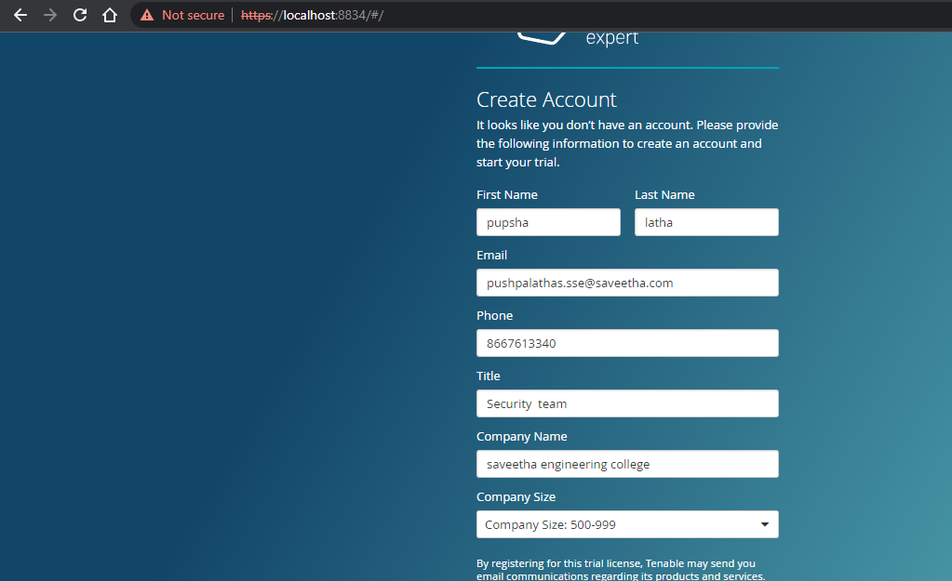

Step 9:- please note down the activation key

## **Trial License Information**

Activation Code: R4A2-DPDT-UVQZ-T53Y

Valid until: 2023-01-28

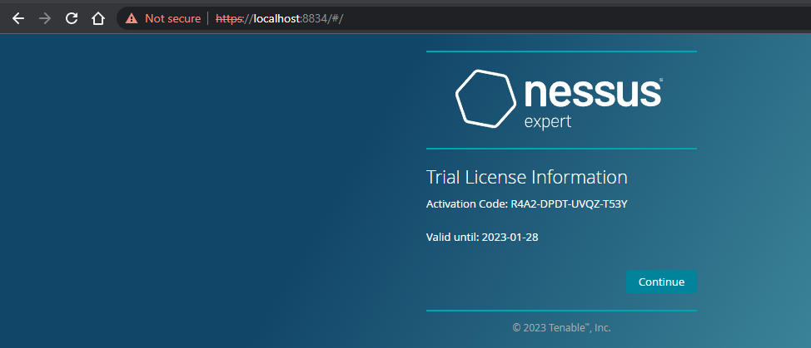

Step 10:- set up your username & password

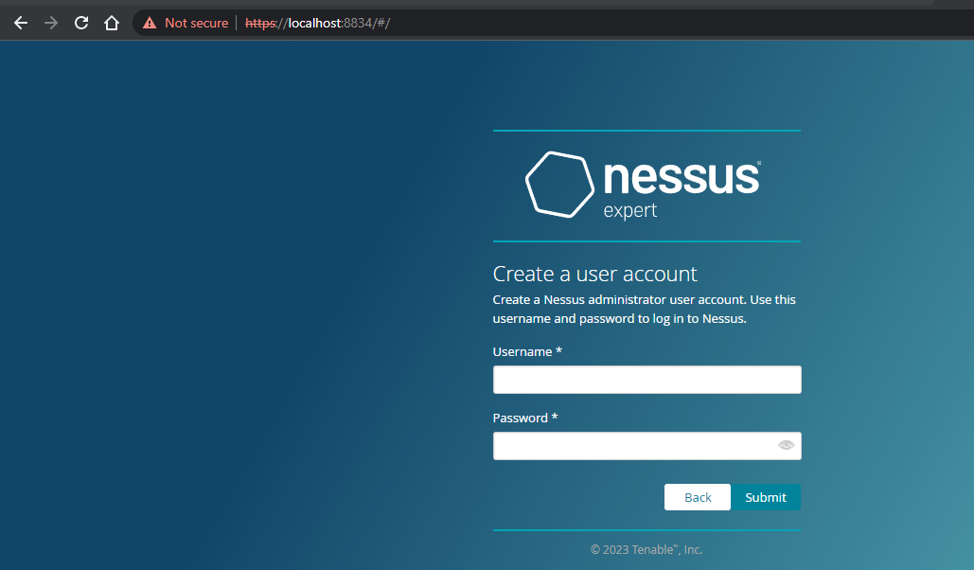

Step 11:-Type username and password

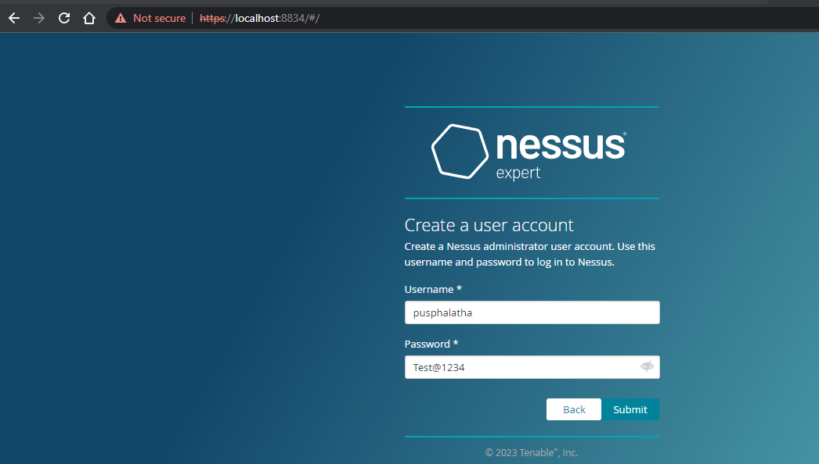

Step 12:- Please wait until download is completed

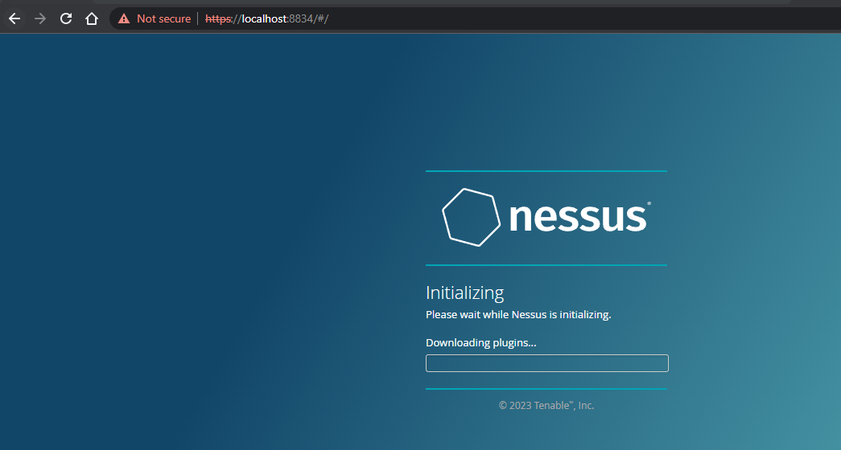

Step 13: Select My Scans

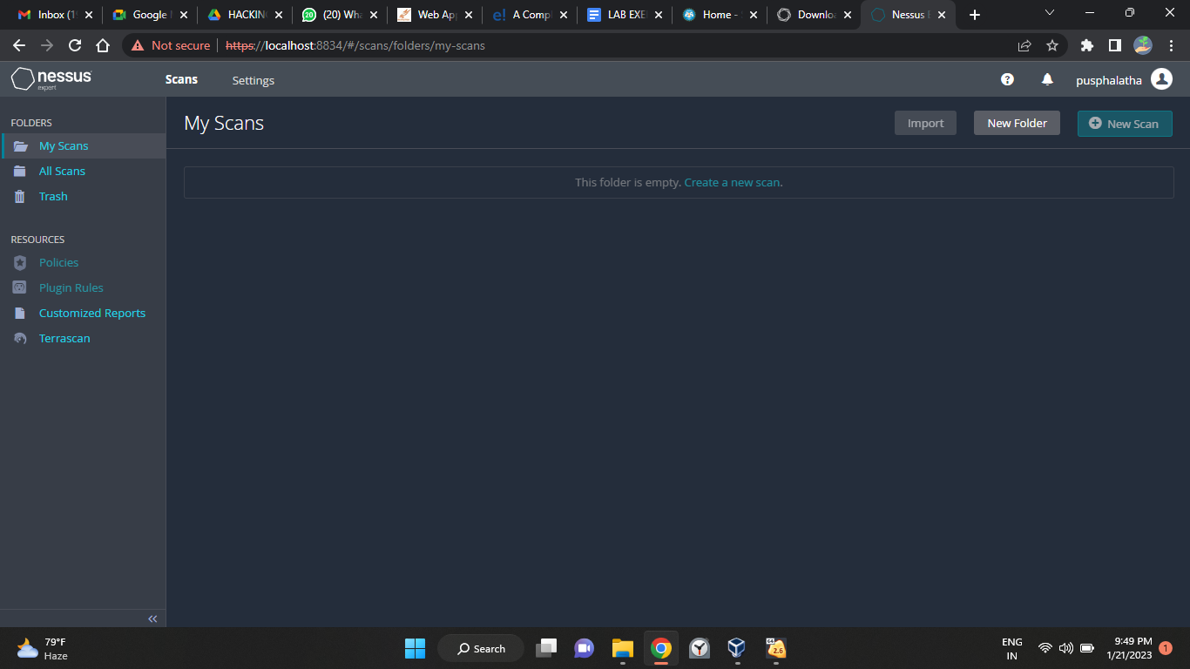

**Exercise No 4:** **Website Penetration Testing**

**Aim:** To demonstrate Website Penetration Testing offered by Kali Linux.

**Procedure:**

Step 1 − To open Vega go to Applications → 03-Web Application Analysis → Vega

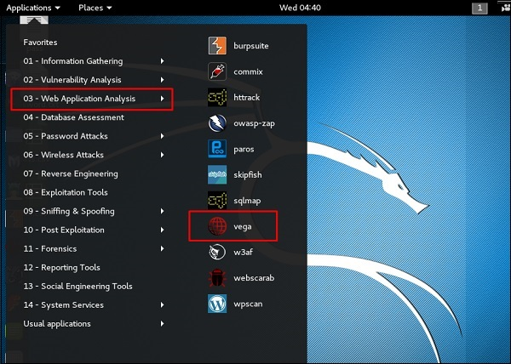

Step 2 − If you don’t see an application in the path, type the following command.

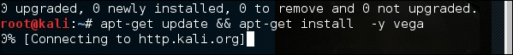

Step 3 − To start a scan, click “+” sign.

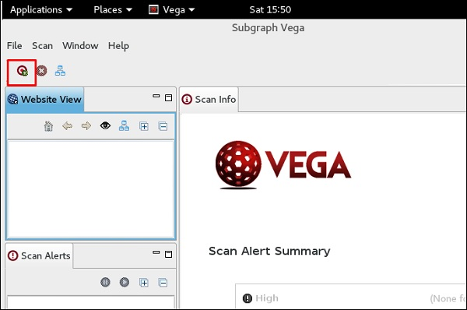

Step 4 − Enter the webpage URL that will be scanned. In this case, it is metasploitable machine → click “ Next”.

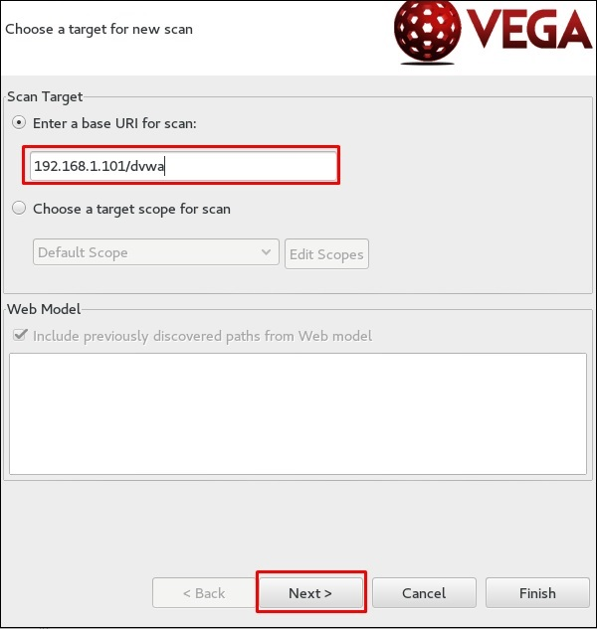

Step 5 − Check all the boxes of the modules you want to be controlled. Then, click “Next”.

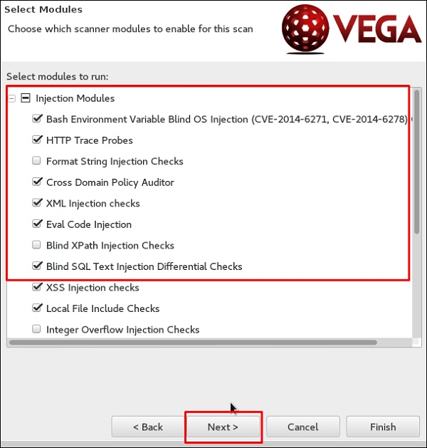

Step 6 − Click “Next” again in the following screenshot.

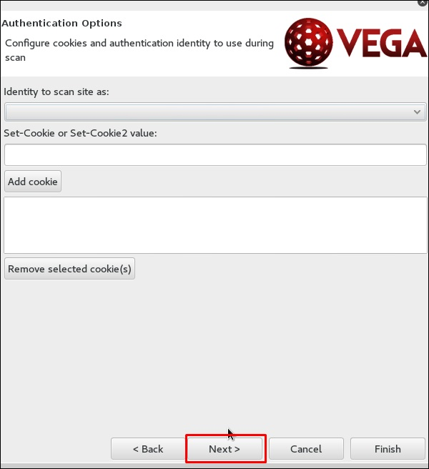

Step 7 − Click “Finish”.

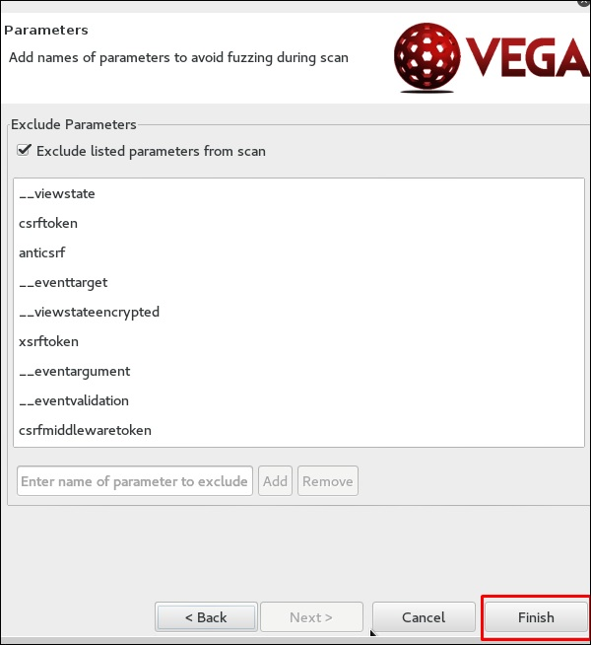

Step 8 − If the following table pops up, click “Yes”.

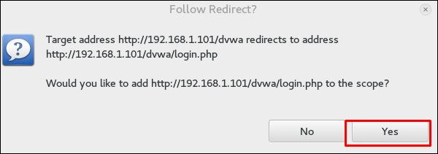

The scan will continue as shown in the following screenshot.

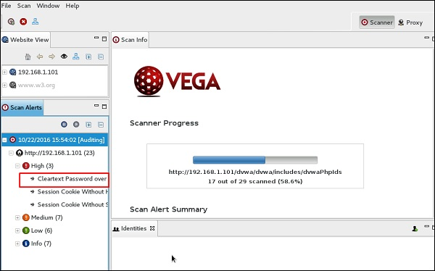

Step 9 − After the scan is completed, on the left down panel you can see all the findings, that are categorized according to the severity. If you click it, you will see all the details of the vulnerabilities on the right panel such as “Request”, ”Discussion”, ”Impact”, and ”Remediation”.

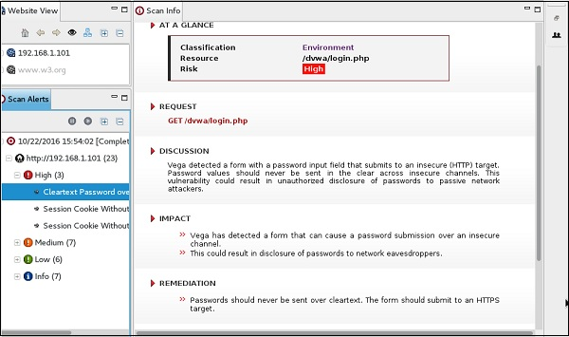

Exercise No 5: Information gathering using theHarvester

Aim: To demonstrate information gathering using theHarvester

Procedure:

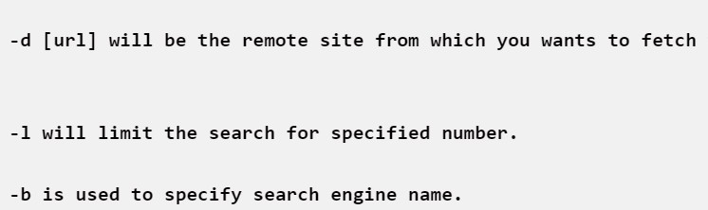**STEP 1: Open Terminal in the kali linux**

**STEP 2: Run the following command**

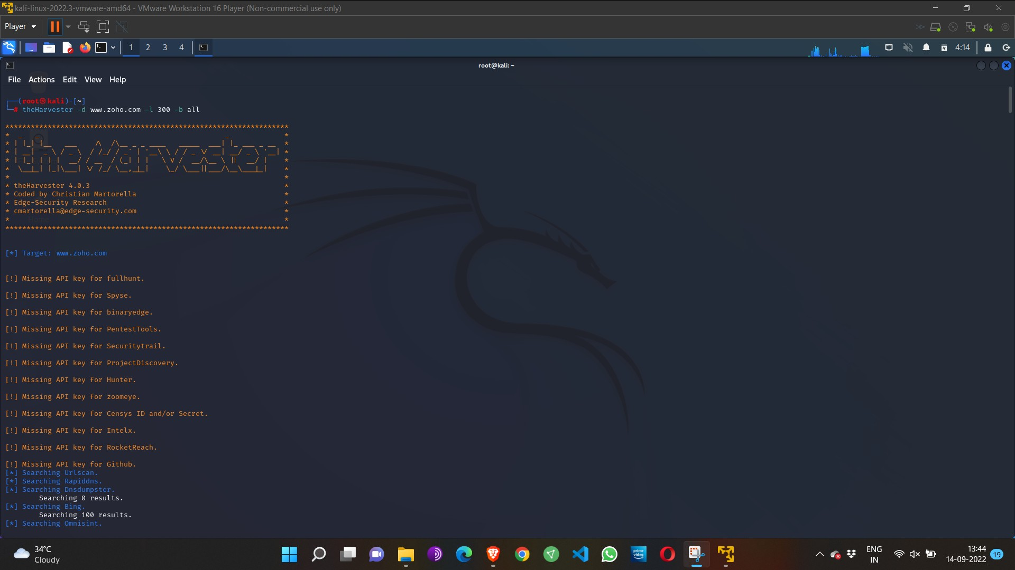**Command: theHarvester -d** [**www.zoho.com**](http://www.zoho.com/) **-l 300 -b all**

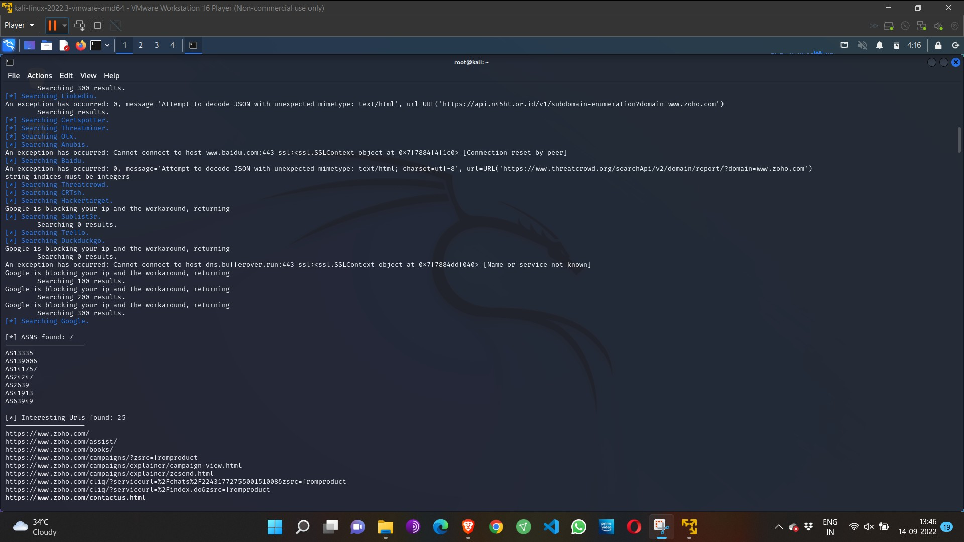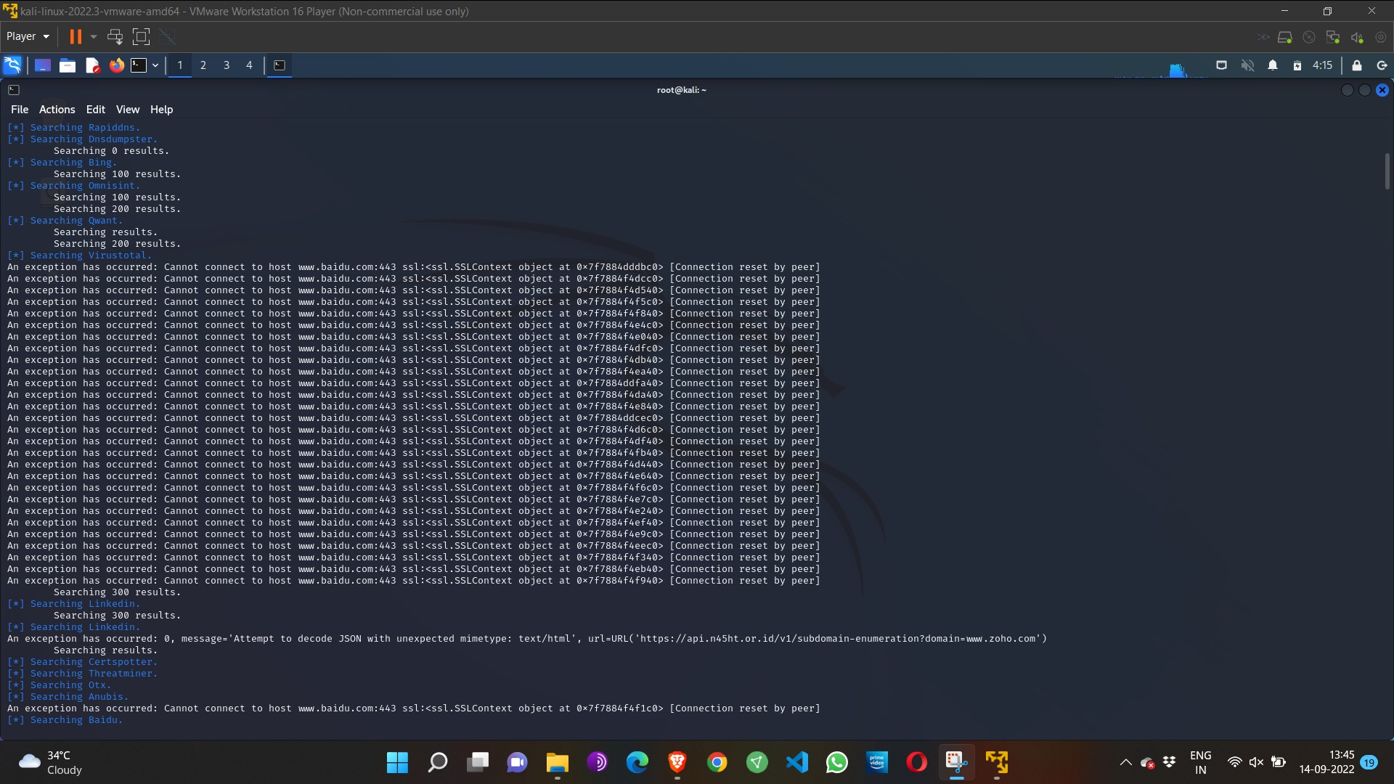

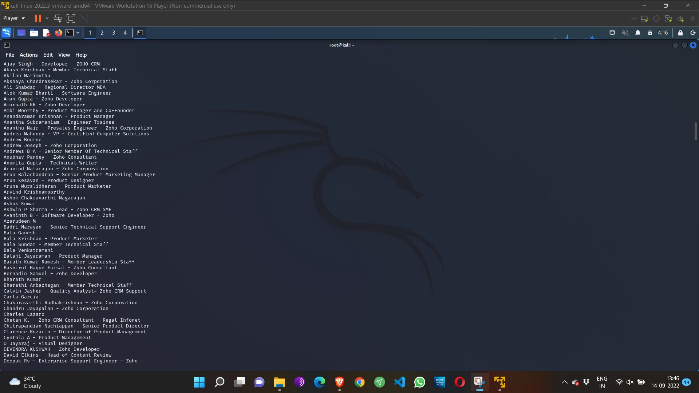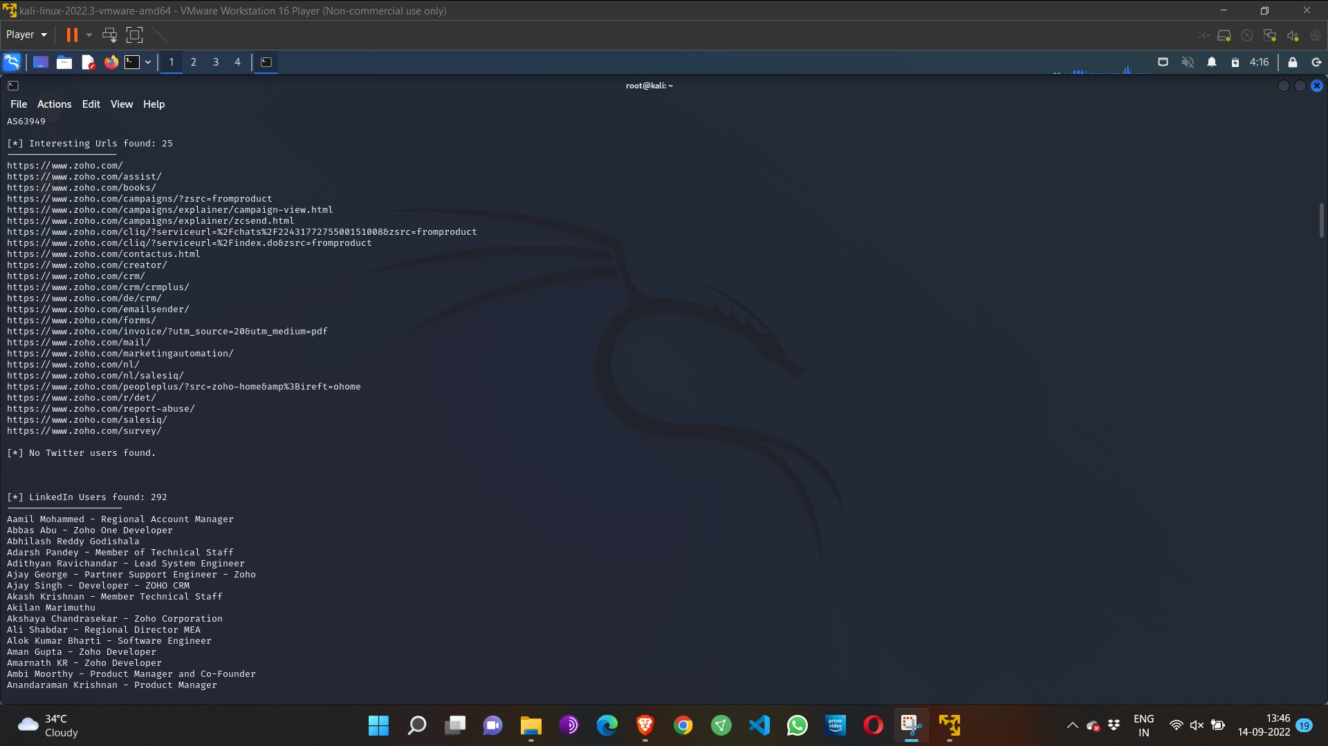

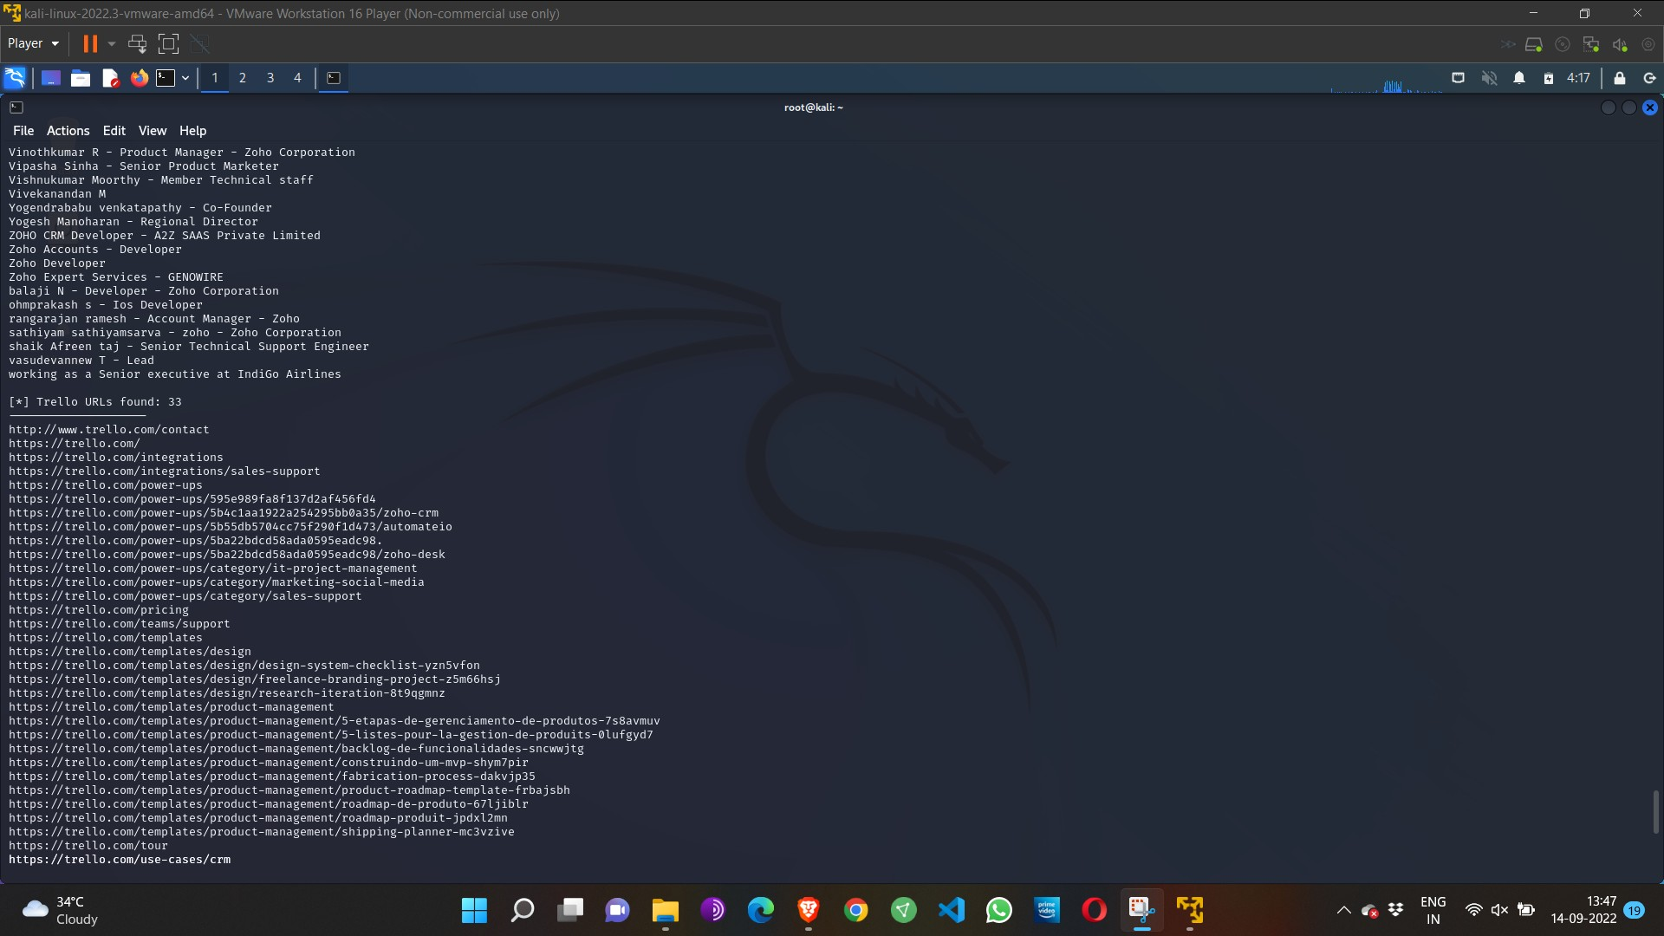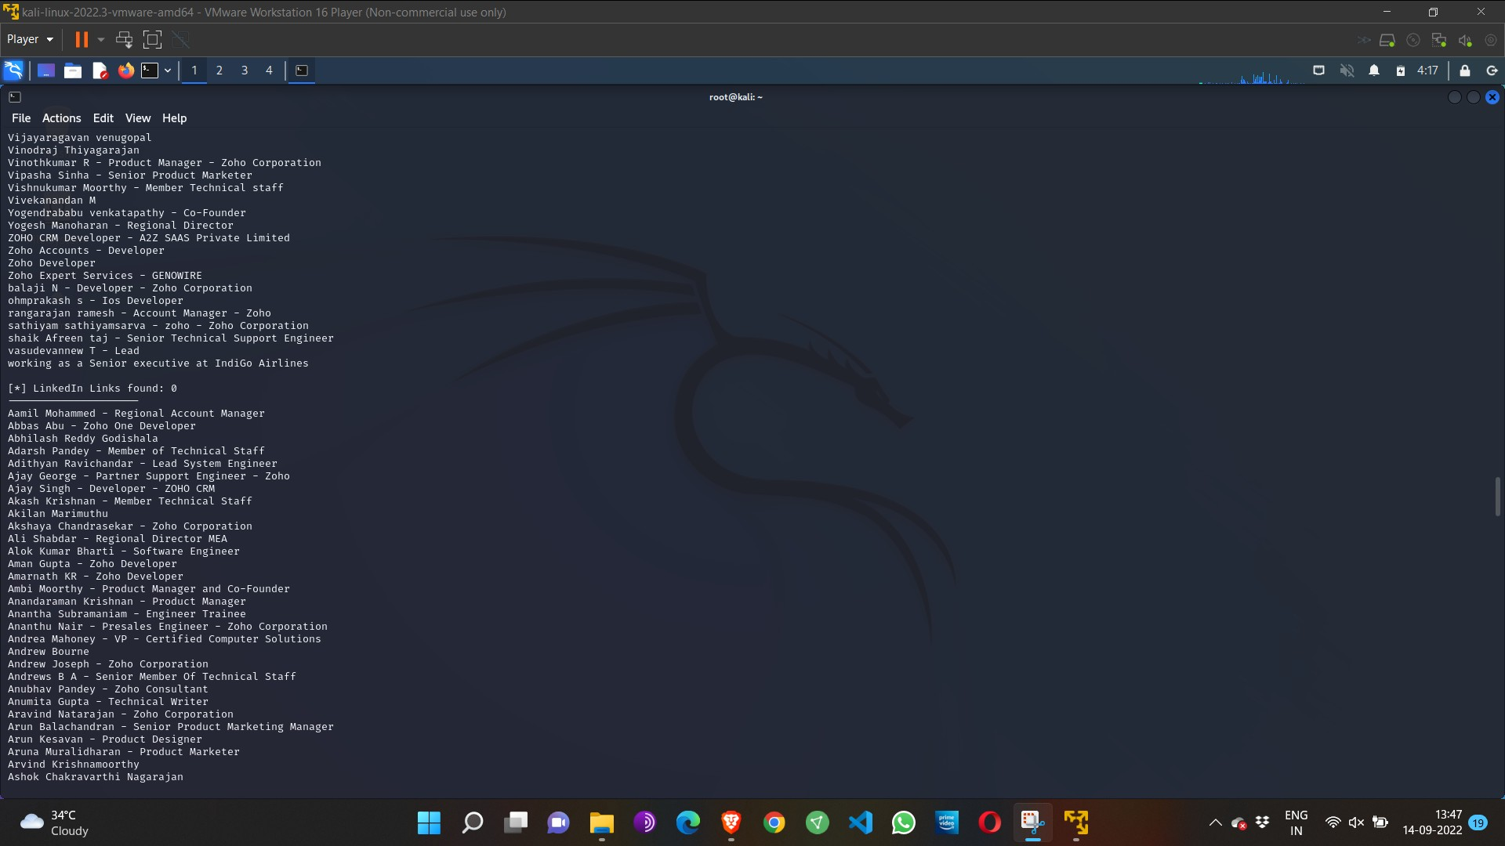

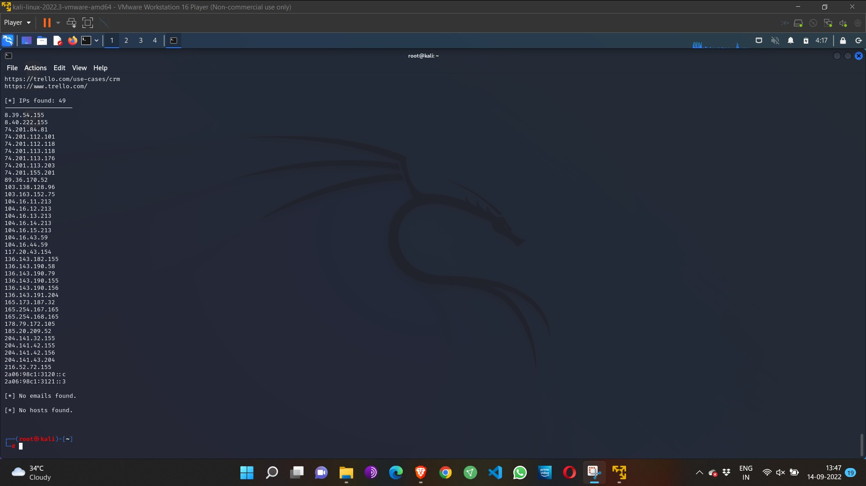

Step 4: run this command “**theHarvester -d** [**www.zoho.com**](http://www.zoho.com/) **-l 300 -b all -f test” and** hit enter to export the result as html file and xml file

Step 5: now close the terminal and navigate the home folder and search for test file .

**Exercise No 6 - Open Source Intelligence Gathering Using OSRFramework**

**Aim:** To Checks for the Existence of a Profile for given user details in different platforms

**Procedure:**

Step 1: Log into kali linux machine

Step 2: Launch a command line terminal by clicking on terminal icon from taskbar

Step 3: Usufy.py checks for the existence of a profile for given user details in different

platforms

**Command:**

## Usufy.py -n <Target username or profile name> -p twitter facebook youtube

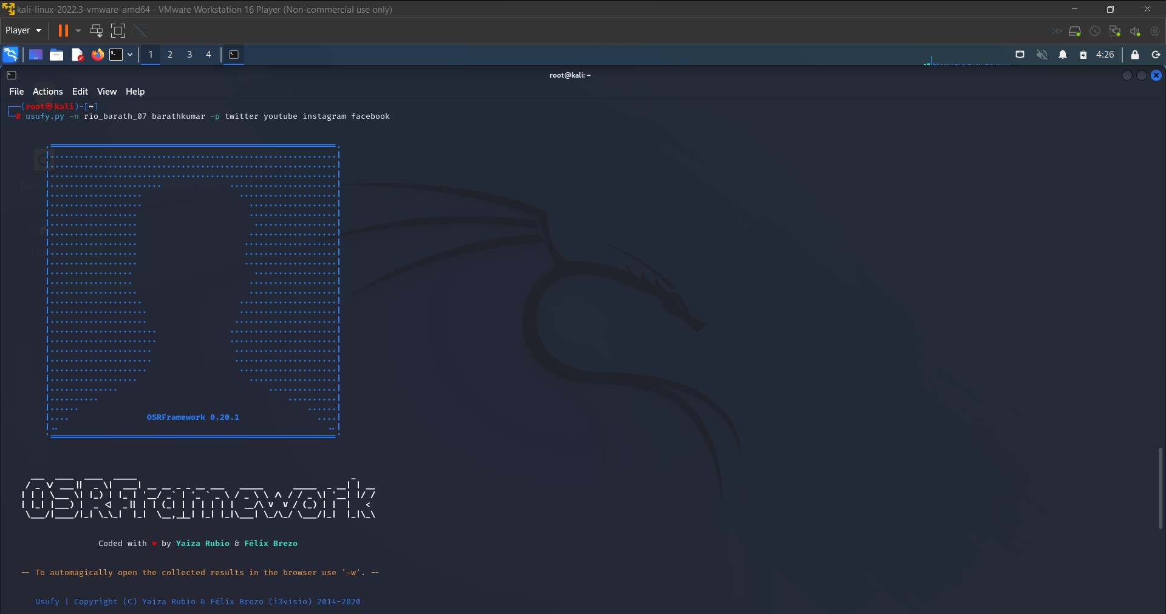

If any error occurs Try this command: **Sudo apt-getupdate**

## The usufy.py will search the user details in the mentioned platform and will provide you with the existence of the user

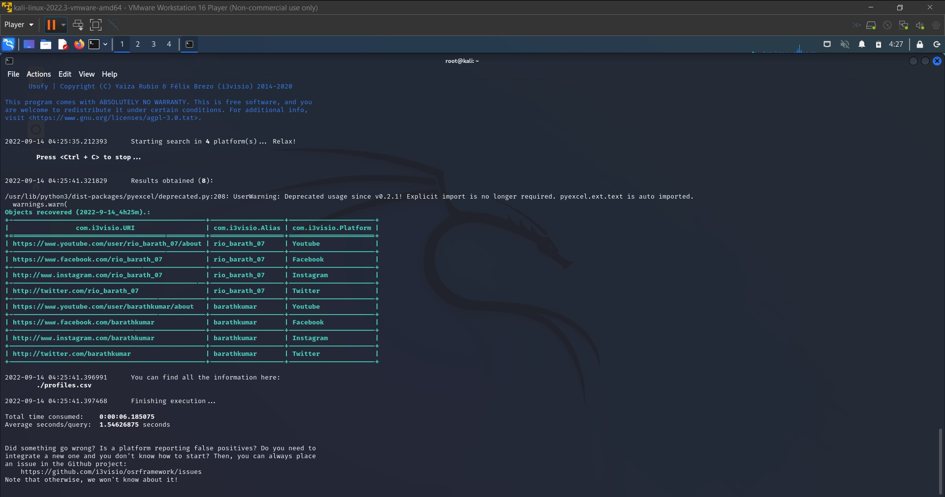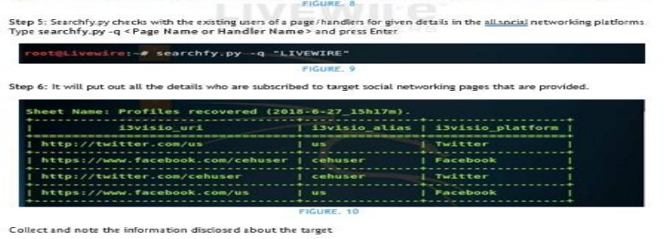

**Exercise NO 7: Use Google and Whois for Reconnaisasance.**

Aim: To find out the Whois, DNS Records and Diagonstics for particular website by using Whois search.

Procedure:

Step1: Open the WHO.is website

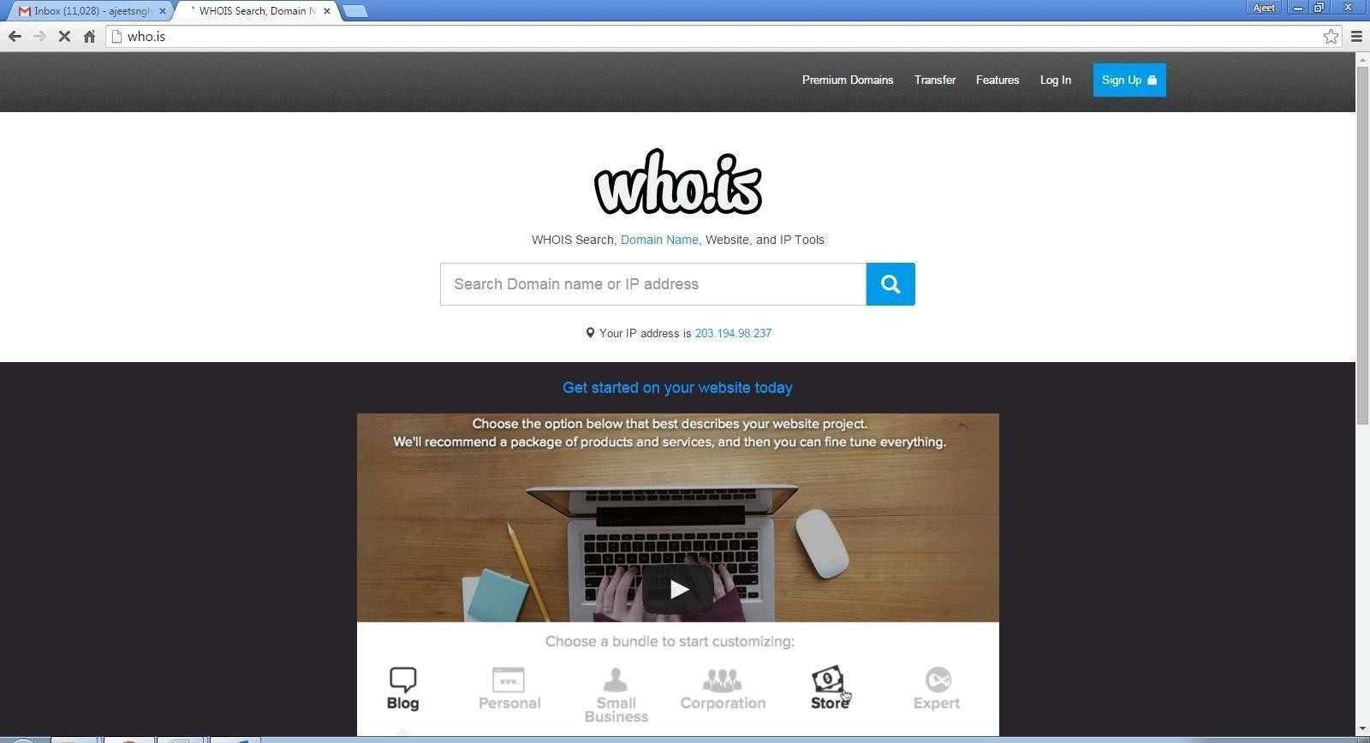

Step 2: Enter the website name in search bar and hit the “Enter button”. Step 3: Show you information about [www.saveetha.com](http://www.saveetha.com/)

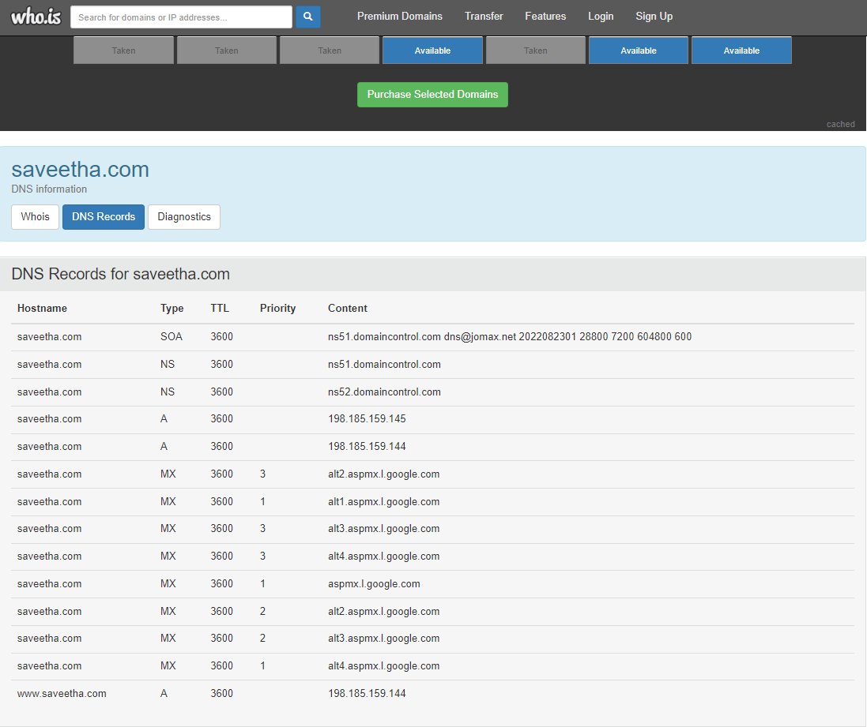

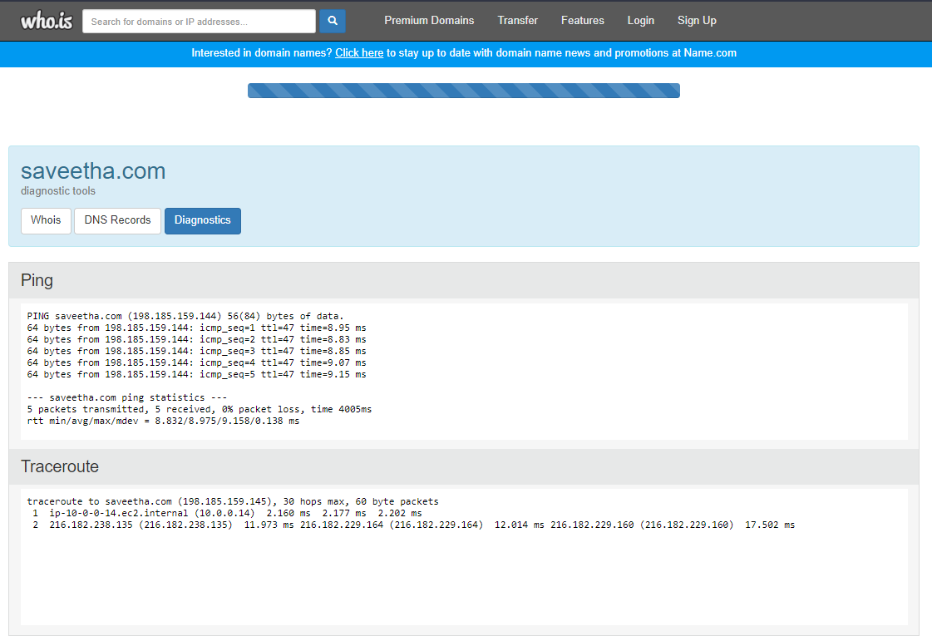

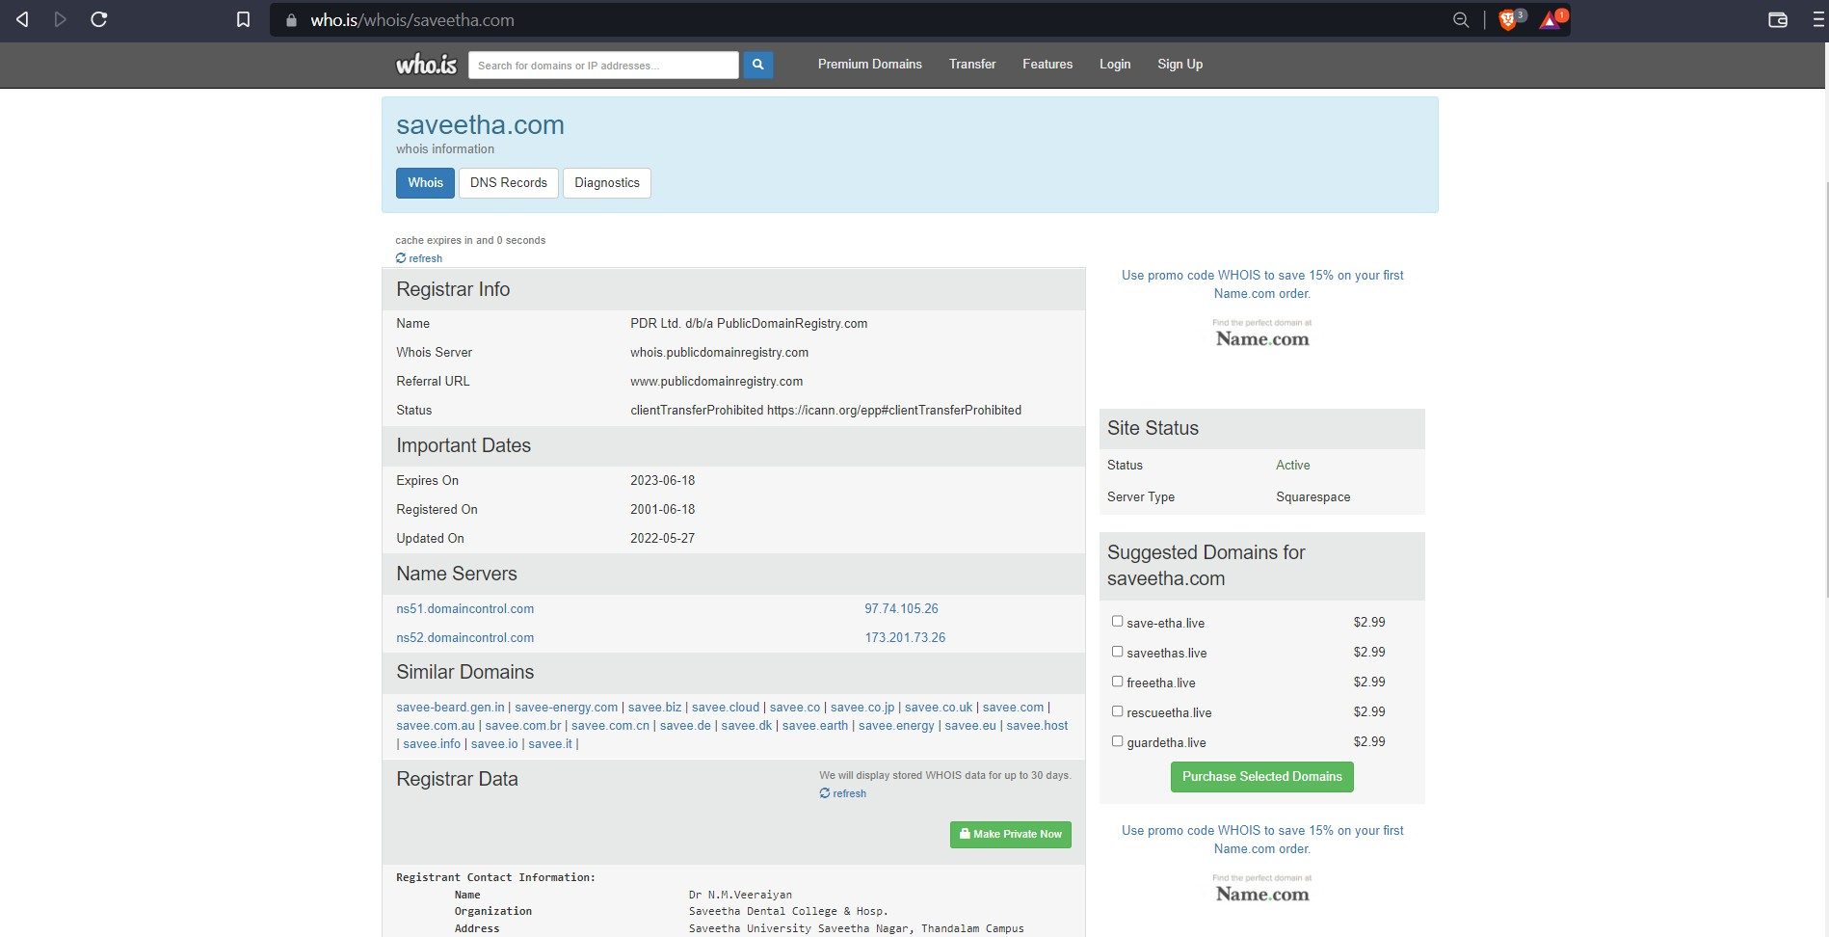

**Exercise No 8: TraceRoute, ping, ifconfig, ipconfig, netstat**

**Aim: Using TraceRoute, ping, ifconfig(LINUX), ipconfig(WINDOWS), and netstat**

**Command.**

Procedure:

Step 1: open windows command prompt and Type tracert command and type tracert

[www.saveetha.com](http://www.saveetha.com/) -> “Enter”

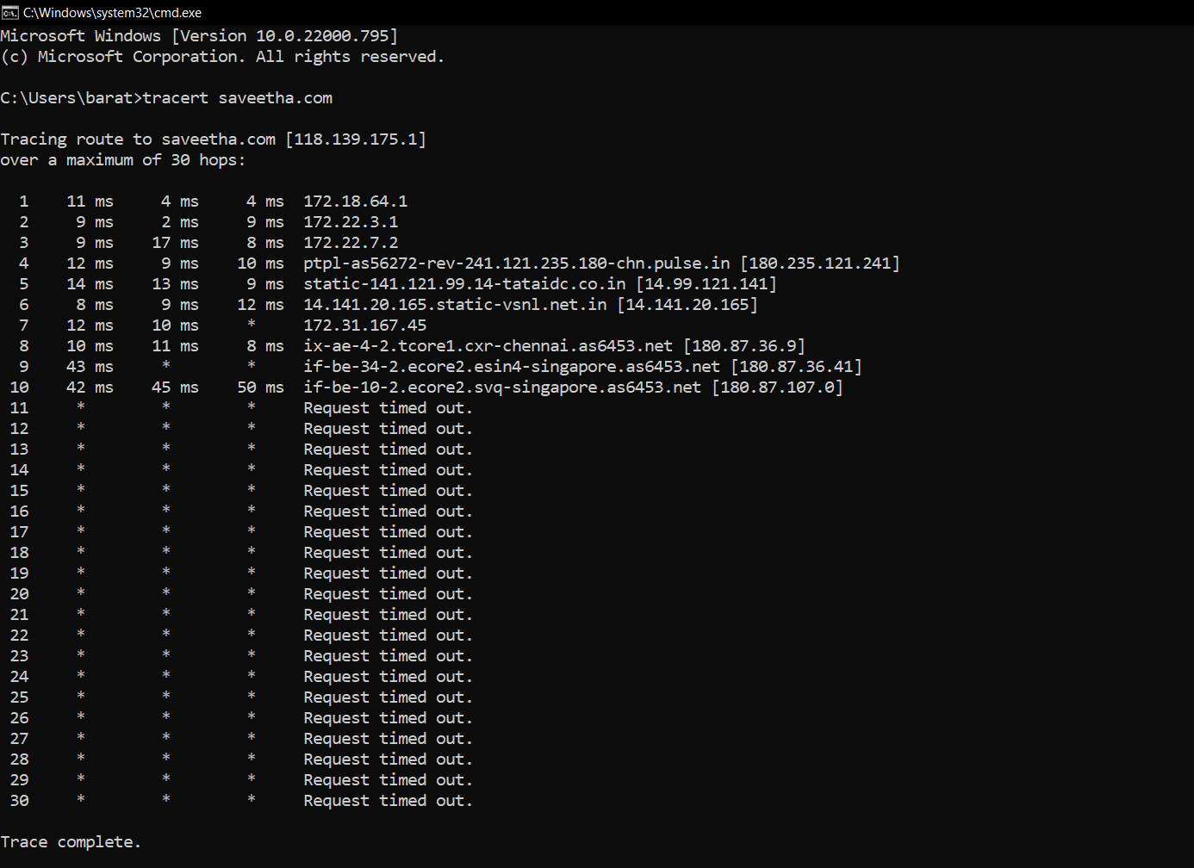

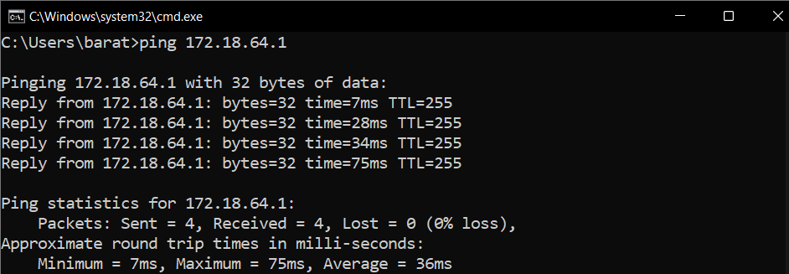Step 2: Type ping command and type IP Address press “Enter”

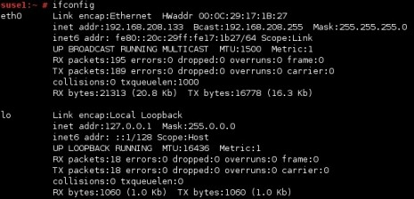Step 3: Type ifconfig command

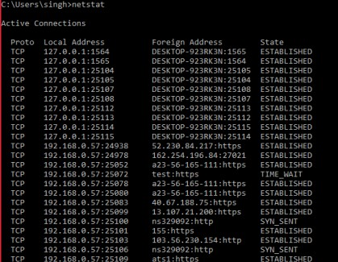Step 4: Type netstat command

Exercise No 9:VULNERABILITY ANALYSIS - CGI Scanning with Nikto

Aim:To perform vulnerability Analysis using CGI Scanning with Nikto

Procedure:

Step 1: open a terminal window and type nikto –H and press enter

Step 2: Type nikto –h <website> Tuning x and press enter

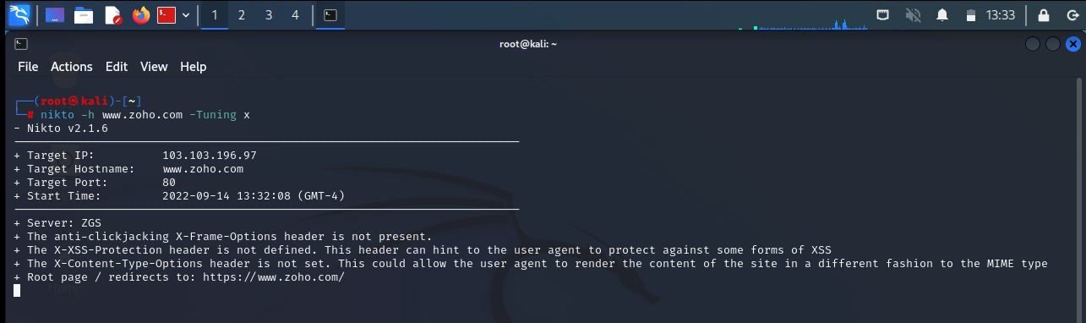

Step 3: Nikto starts web server scanning with all tuning options enabled.

Step4:In the terminal window type “nikto –h <website>-Cgidirs all”and hit enter

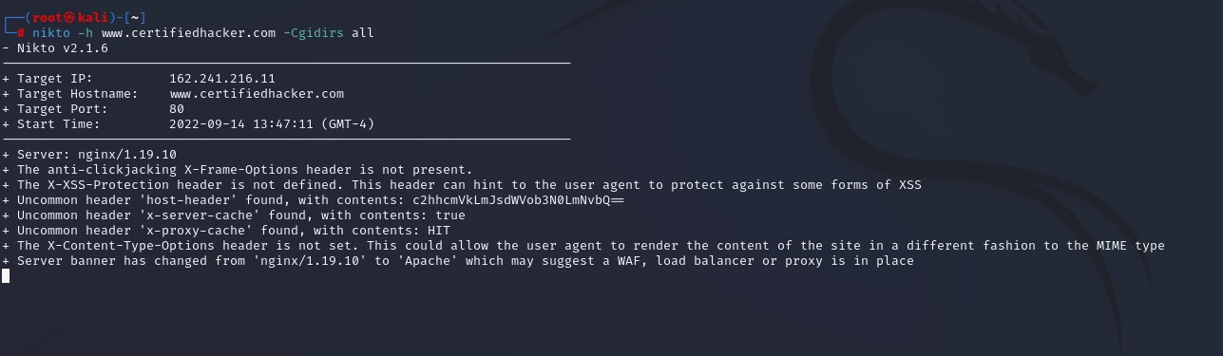

Step 5. Nikto will scan the webserver as it looks vulnerable CGI directories. It scans the webserver and list out the directories

**Exercise No 6: WireShark sniffer**

**Aim: Use WireShark sniffer to capture network traffic and analyze.**

Procedure:

Step 1: Install and open WireShark .

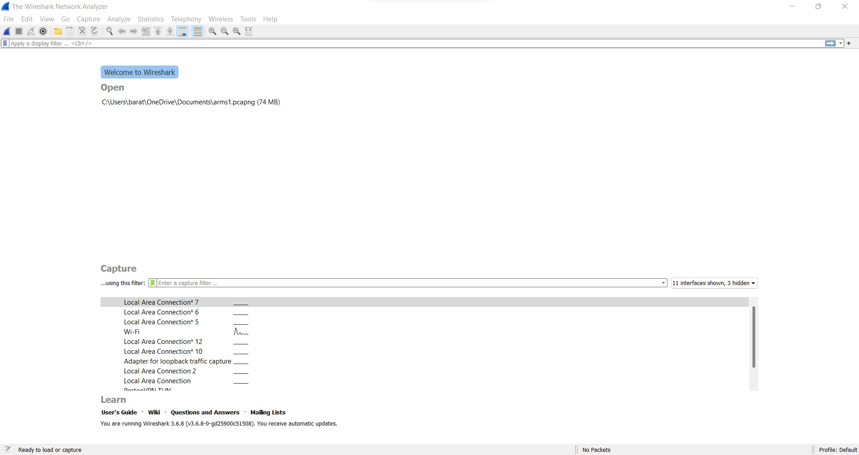

Step 2: Go to Capture tab and select Interface option. Here Wifi connection is chosen

Step 3: The source, Destination and protocols of the packets in the Wifi network are displayed

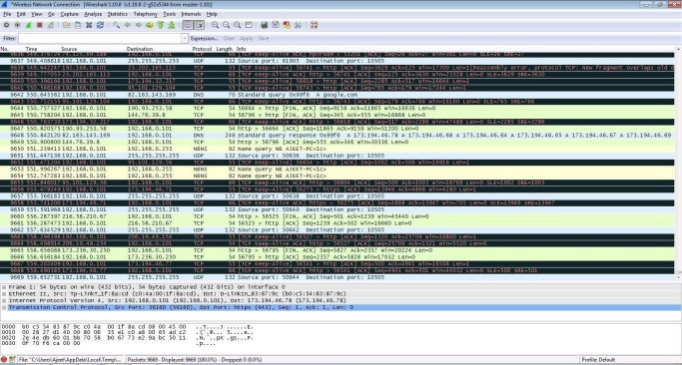

Step 4: Open a website in a new window and enter the user id and password. Register if needed.

Step 5:Enter the credentials and then sign in

Step 6: The wireshark tool will keep recording the packets.

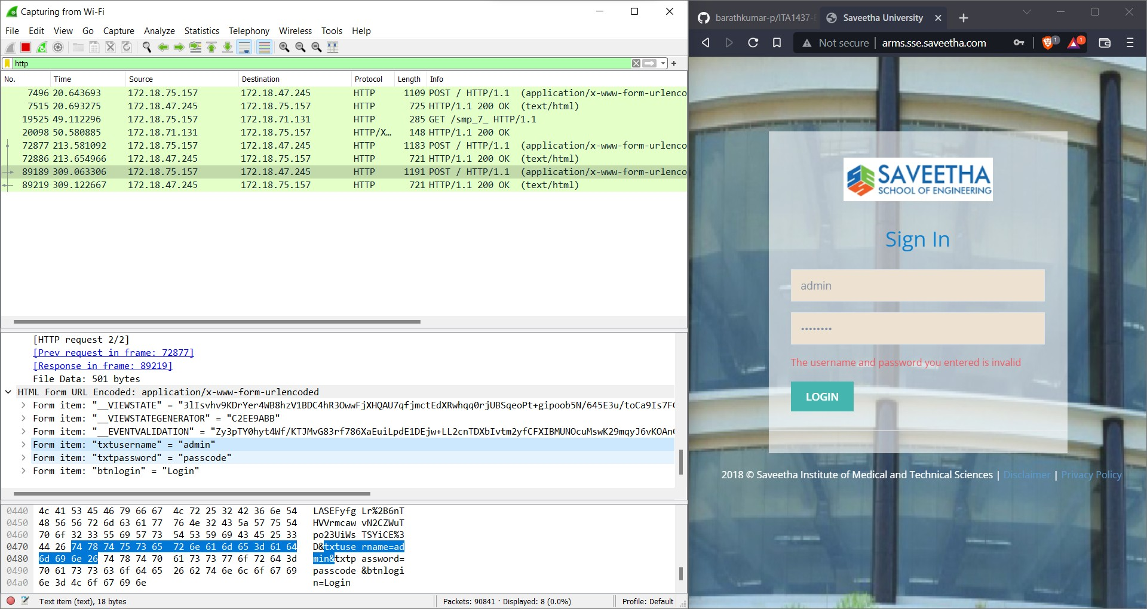Step 7: Select filter as http to make the search easier and click on apply. Step 9: Now stop the tool to stop recording

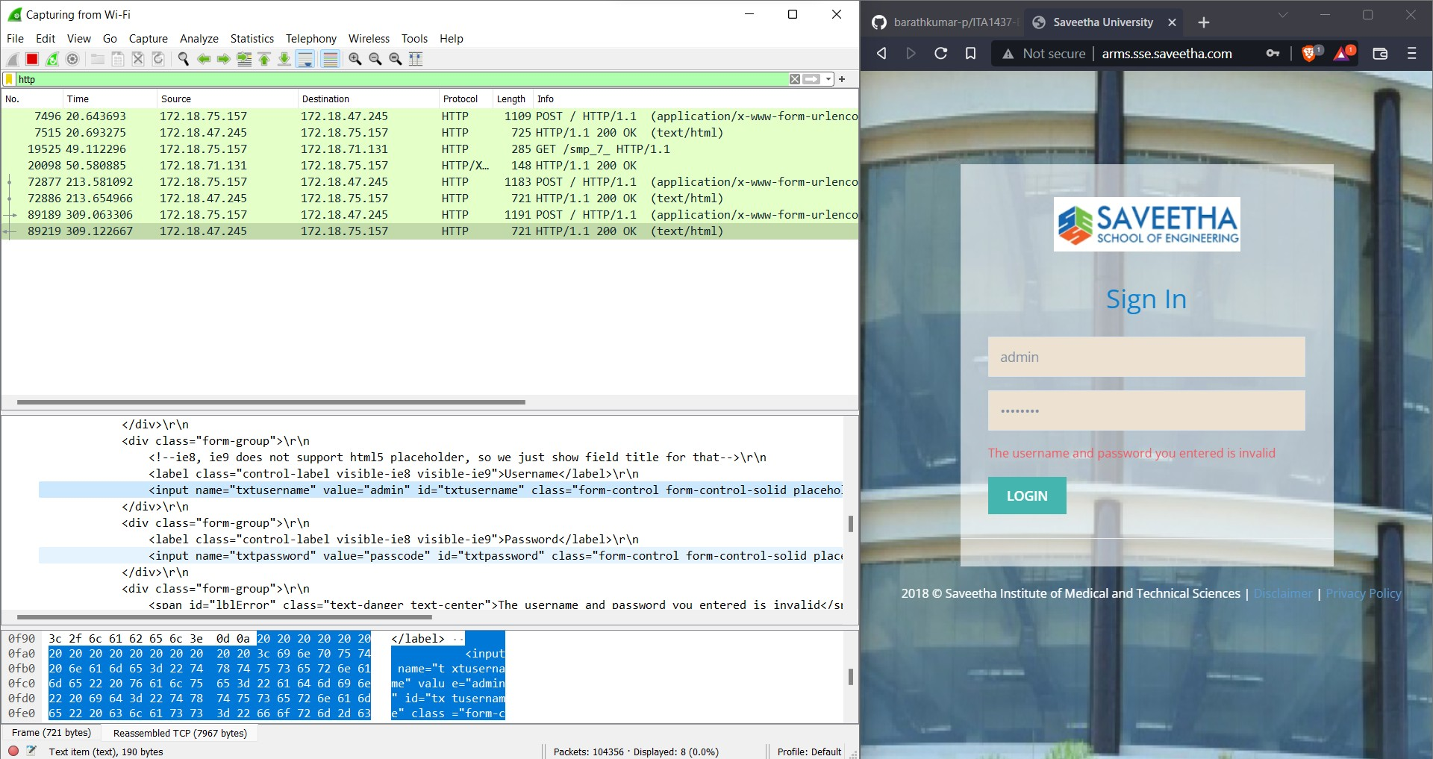

Step 10: Find the post methods for username and passwords

Step 11: U will see the email- id and password that you used to log in.

